**OOPJ**

**Assignment No- 2**

1)Write a program that checks if a given year is a leap year or not using both if-else and switch-case.

**Solution—**

import java.util.Scanner;

public class LeapYear {

public static void main(String[] args) {

Scanner sc = new Scanner(System.in);

System.out.print("Enter a year: ");

int year = sc.nextInt();

int l;

if (year % 400 == 0) {

l= 0;

} else if (year % 100 == 0) {

l = 1;

} else if (year % 4 == 0) {

l = 0;

} else {

l = 1;

}

switch (l) {

case 0:

System.out.println(year + " is a leap year.");

break;

case 1:

System.out.println(year + " is not a leap year.");

break;

default:

System.out.println("Invalid input.");

break;

}

}

}

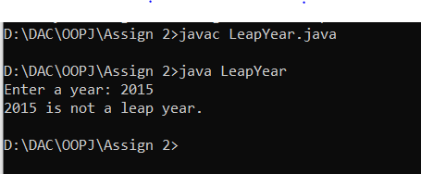

2)Implement a program that calculates the Body Mass Index (BMI) based on height and weight input using if-else to classify the BMI int categories (underweight, normal weight, overweight,etc).

**Solution—**

import java.util.*;

public class BMICalc {

public static void main(String[] args) {

Scanner sc= new Scanner(System.in);

System.out.print("Enter your weight in kilograms: ");

double w = sc.nextDouble();

System.out.print("Enter your height in meters: ");

double h = sc.nextDouble();

double bmi = w / (h * h);

System.out.printf("Your BMI is: %.2f%n", bmi);

if (bmi < 18.5) {

System.out.println("You are underweight.");

} else if (bmi >= 18.5 && bmi < 24.9) {

System.out.println("You have a normal weight.");

} else if (bmi >= 25 && bmi < 29.9) {

System.out.println("You are overweight.");

} else if (bmi >= 30 && bmi < 39.9) {

System.out.println("You are obese");

} else {

System.out.println("You are extremely obese ");

}

}

}

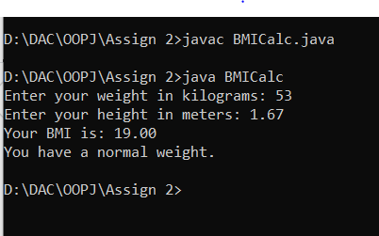

3)Write a program that checks if a person is eligible to vote based on their age.

**Solution—**

import java.util.*;

import java.io.*;

public class VoteAge

{

public static void main(String[] args)

{

System.out.println("Enter your age");

Scanner sc= new Scanner(System.in);

int n= sc.nextInt();

if(n>=8)

System.out.println("You are eligible to vote");

else

System.out.println("You are not eligible to vote");

}

}

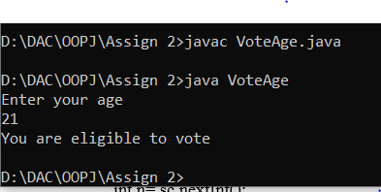

4)Write a program that takes a month (1-12) and prints the corresponding season (Winter, Spring, Summer, Autumn) using a switch case

**Solution--**

import java.util.*;

import java.io.*;

public class Month

{

public static void main(String[] args)

{

System.out.println("Enter the number corresponding to the month");

Scanner sc= new Scanner(System.in);

int n= sc.nextInt();

switch(n)

{

case 1: case 12: case 2:

System.out.println("Winter");

break;

case 3: case 4: case 5:

System.out.println("Spring");

break;

case 6: case 7: case 8:

System.out.println("Summer");

break;

case 9: case 10 : case 11:

System.out.println("Autumn");

break;

default:

System.out.println("Invalid option");

}

}

}

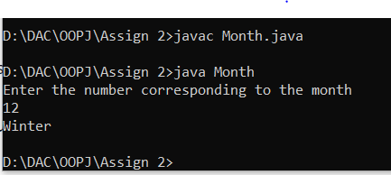

5)Write a program that allows the user to select a shape (Circle, Square, Rectangle, Triangle) and then calculates the area based on user-provided dimensions using a switch case.

**Solution—**

import java.util.*;

import java.io.*;

public class Area

{

public static void main(String[] args)

{

System.out.println("Select a shape : 1.Circle 2.Square 3.Rectangle 4.Triangle");

Scanner sc= new Scanner(System.in);

int n= sc.nextInt();

double area=0;

switch(n)

{

case 1:

System.out.println("Enter the radius");

double r= sc.nextDouble();

area= Math.PI*r*r;

break;

case 2:

System.out.println("Enter the side");

double s= sc.nextDouble();

area= s*s;

break;

case 3:

System.out.println("Enter the length and width");

double l= sc.nextDouble();

double w= sc.nextDouble();

area= l*w;

break;

case 4:

System.out.println("Enter the height and base");

double h= sc.nextDouble();

double b= sc.nextDouble();

area= (h*b)/2;

break;

default:

System.out.println("Invalid option");

}

System.out.println("Area is : "+area);

}

}

